PMI #918 Registration Tape

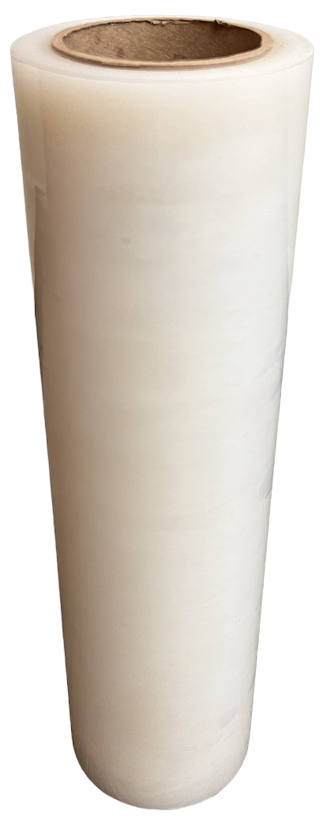
The PMI #918 Registration Tape allows you to quickly register prints.

Apply the #918 Registration Tape over the top of the garment before printing the garment. Print multiple colors on top of the #918 Registration Tape. If a color is out of registration, the ink wipes off of the surface of the #918 Registration Tape allowing you to adjust the registration and test again.

When the colors are in registration and you’re ready to print, the #918 Registration Tape will remove cleanly from the garment.

Item Specifications
- Roll Size: 16”X200’
- Material: Removable Adhesive on Flexible Clear Polyethylene
- Adhesive Thickness: 0.5 mil
- Polyethylene Thickness: 2.3 mil
- Tensile Strength: 8.0 lb/in
- Adhesion: 13.5 oz/in

